Lucky Pawar
Genre Prediction from Spotify Audio Features
DTSC 2302

Introduction
Music is often considered subjective, shaped by culture, emotion, and personal taste. However, modern streaming platforms rely heavily on data to organize and recommend songs. This raises an important question: can the measurable characteristics of a song’s audio be used to predict its genre?
This project aims to build and evaluate machine learning models that classify a song’s genre based on its audio features. By analyzing variables such as energy, danceability, and acousticness, this study investigates whether musical genres are reflected in objective, quantifiable patterns.

Dataset & Problem Framing
The dataset used in this project includes Spotify tracks with associated audio features and genre labels. Each row represents a single song, and the dataset contains numerical variables such as danceability, energy, loudness, speechiness, acousticness, valence, and tempo.
The target variable is track_genre, which identifies the genre of each song. To create a balanced and manageable classification problem, the dataset was restricted to the five most common genres: acoustic, afrobeat, power-pop, progressive-house, and psych-rock. This ensures that each class contains a similar number of observations and prevents bias.
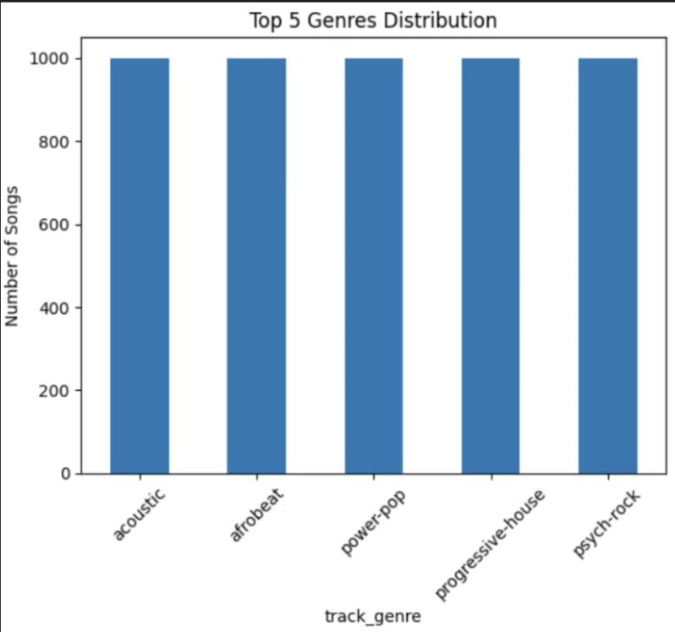
Figure 1: Distribution of songs across the top five genres.

Data Preprocessing & Assumptions
Several preprocessing steps were performed to prepare the dataset for modeling. First, unnecessary columns such as unnamed indices and non-numeric identifiers were removed, as they do not contribute meaningful information for predicting genre. Removing these variables helps reduce noise and simplifies the model.
Rows containing missing values were dropped to ensure data consistency and avoid introducing bias through imputation. While this reduces the total number of observations, it ensures that all remaining data points are complete and reliable.
Only numerical audio features were selected as input variables. This decision reflects the assumption that genre can be predicted from measurable sound characteristics alone. By excluding metadata such as artist or album name, the model focuses entirely on the structure of the music rather than external influences.
A key trade-off in this approach is that some contextual information is lost. However, this allows for a clearer analysis of how audio features alone contribute to genre classification.

Exploratory Data Analysis
Exploratory data analysis was conducted to understand how audio features vary across genres. This step is important because it helps determine whether meaningful patterns exist before applying machine learning models.
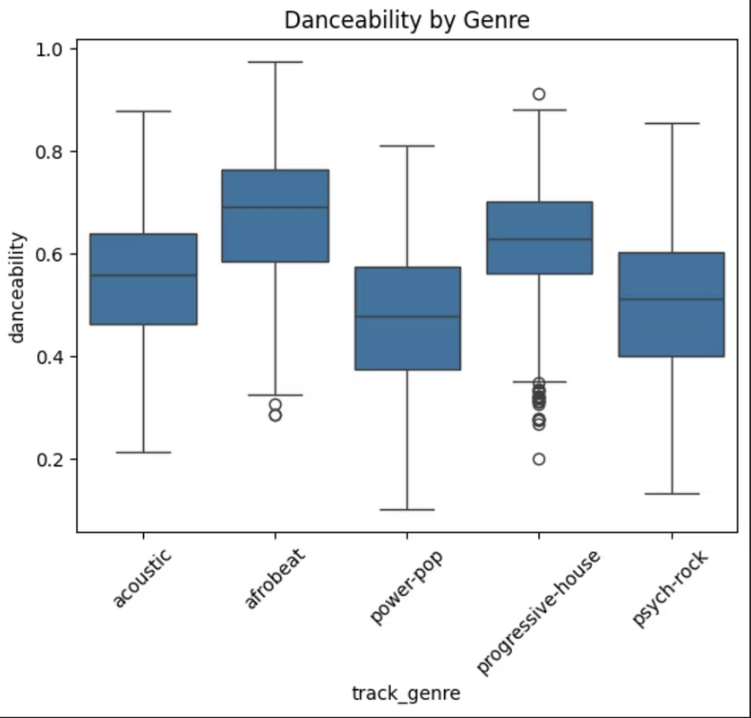
Figure 2: Distribution of danceability across genres.
The distribution of danceability shows that certain genres, such as power-pop and progressive-house, tend to have higher values, while acoustic tracks generally exhibit lower danceability. This indicates that rhythmic structure and beat intensity differ across genres.
.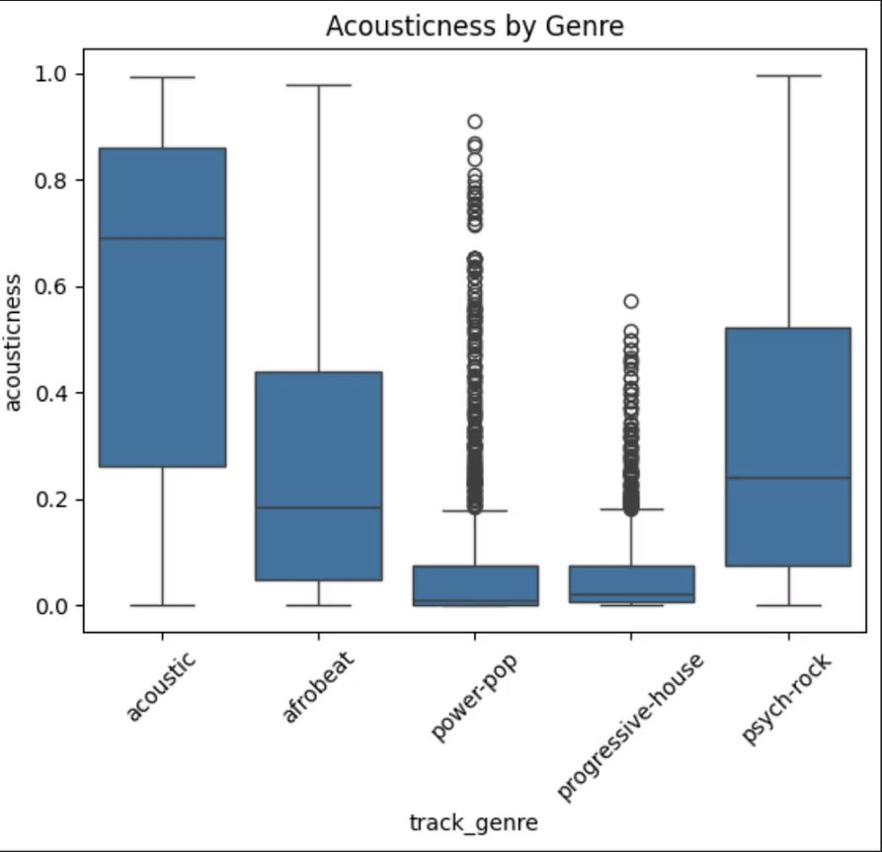
Figure 3: Distribution of acousticness across genres.
Acousticness shows a clear separation between genres. Acoustic tracks have significantly higher values, while electronically produced genres have much lower values. This strong distinction suggests that acousticness is a highly informative feature for classification.
Overall, these visualizations demonstrate that genres are not randomly assigned but are associated with distinct patterns in audio features.

Model Experiments

Three machine learning models were implemented and compared: Logistic Regression, Decision Tree, and Random Forest. Logistic Regression was used as a baseline model because it assumes a linear relationship between features and the target variable. This makes it easy to interpret, but limits its ability to capture complex patterns. The Decision Tree model was used to capture nonlinear relationships by splitting the data based on feature values. This allows the model to identify interactions between features that a linear model cannot capture. The Random Forest model extends the decision tree approach by combining multiple trees into an ensemble. This reduces overfitting and improves generalization by averaging predictions across many trees. These models were chosen to represent increasing levels of complexity, allowing for a comparison between simple and more advanced approaches.

Model Evaluation & Interpretation
Model performance was evaluated using accuracy, precision, recall, and F1-score. Logistic Regression achieved an accuracy of approximately 63%, while the Decision Tree achieved around 59%. The Random Forest model performed slightly better at 70% and produced more stable predictions across genres. To interpret these results, it is important to compare them to a baseline. With five possible genres, random guessing would yield approximately 20% accuracy. All models significantly outperform this baseline, indicating that the features contain meaningful predictive information. However, accuracy alone does not tell the full story. The classification reports show that performance varies across genres. Progressive house achieved a relatively high recall, meaning the model was able to correctly identify a large proportion of songs in this genre. This suggests that it has distinct audio characteristics. In contrast, genres such as afrobeat and psych-rock showed lower recall and precision, indicating that these genres share overlapping features with others. This makes them more difficult to distinguish and highlights the limitations of the models.

Feature Importance
Feature importance from the Random Forest model shows that energy, loudness, and acousticness are most influential.
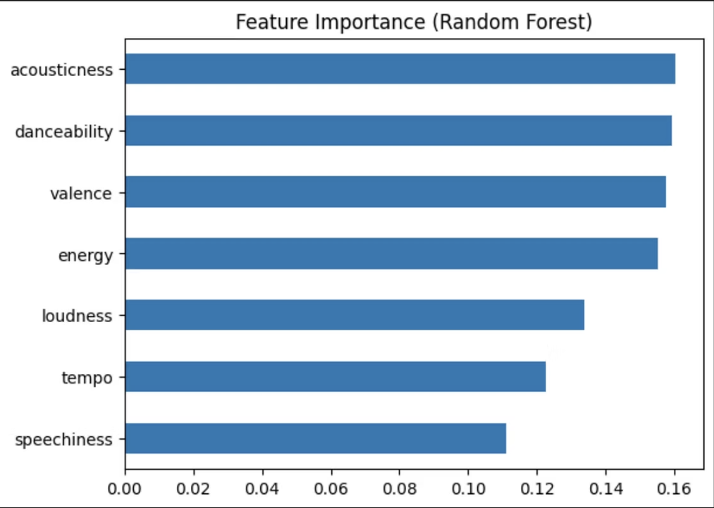
Figure 4: Feature importance from the Random Forest model.
The results show that features such as energy, loudness, and acousticness are among the most important for classification. These features relate to the intensity and production style of a song, which are key factors in distinguishing between genres. This aligns with the findings from the exploratory analysis, providing consistency between observed patterns and model behavior.

Limitations & Reflection
This analysis has several limitations. First, genre labels are inherently subjective and may not always reflect clear boundaries between musical styles. This introduces noise into the target variable and limits model performance. Second, the dataset was restricted to only five genres, which simplifies the classification task but reduces the generalizability of the results. Real-world music classification involves many more genres with greater overlap. Additionally, the model relies solely on audio features and does not account for other important factors such as lyrics, cultural context, or artist influence. These factors can significantly impact how music is categorized. Despite these limitations, the project demonstrates that audio features provide meaningful information for genre classification while also highlighting the complexity of music.

Conclusion
This project demonstrates that audio features can be used to predict a song’s genre with moderate accuracy. While the models do not achieve perfect classification, they significantly outperform random guessing and reveal meaningful patterns in the data. The results suggest that musical genres are partially reflected in measurable properties of sound. At the same time, overlap between genres highlights the complexity of music and the limitations of relying solely on audio features.

References & AI Transparency
Dataset: Spotify Tracks Dataset (Kaggle)
Libraries: pandas, numpy, matplotlib, seaborn, scikit-learn
AI Usage: ChatGPT assisted with structuring and explanation.

